Hoạt Động Tuần 3:

1. Tham khảo trang web https://nhataostore.com/

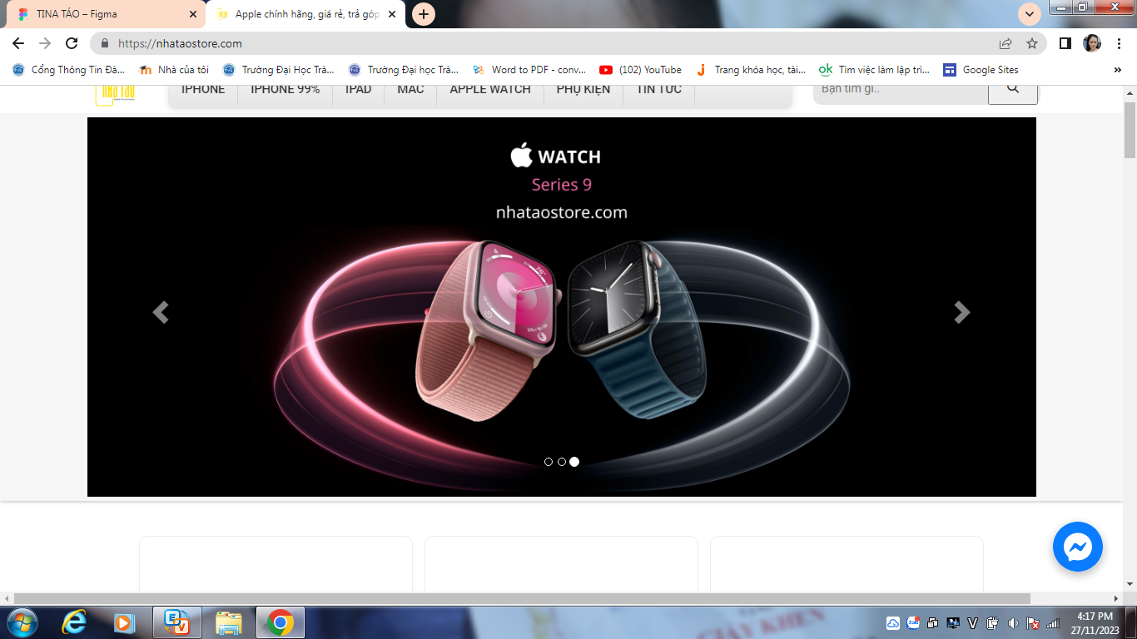

* 1. Trang sản phẩm của Iphone

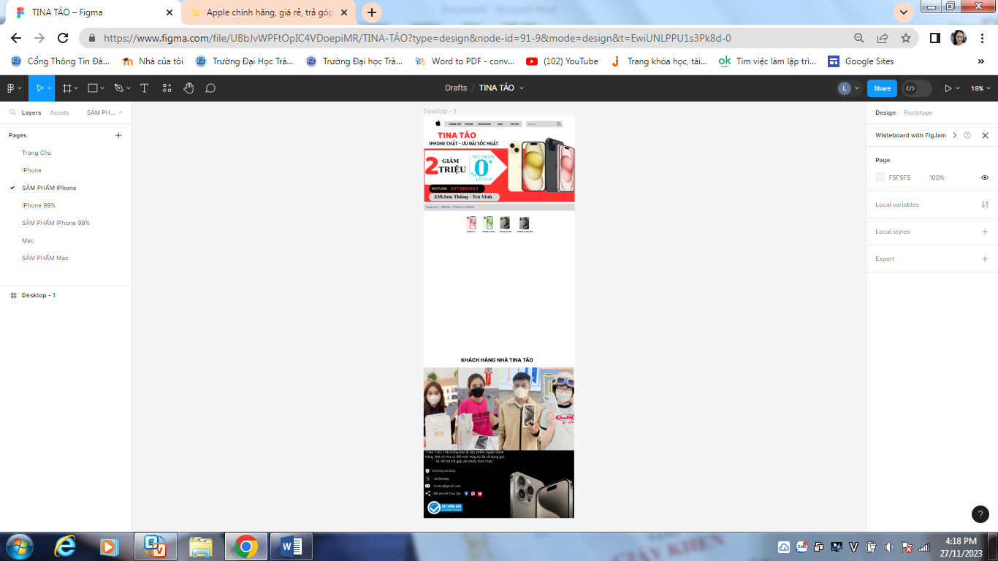

* 1. Trang Iphone 99%

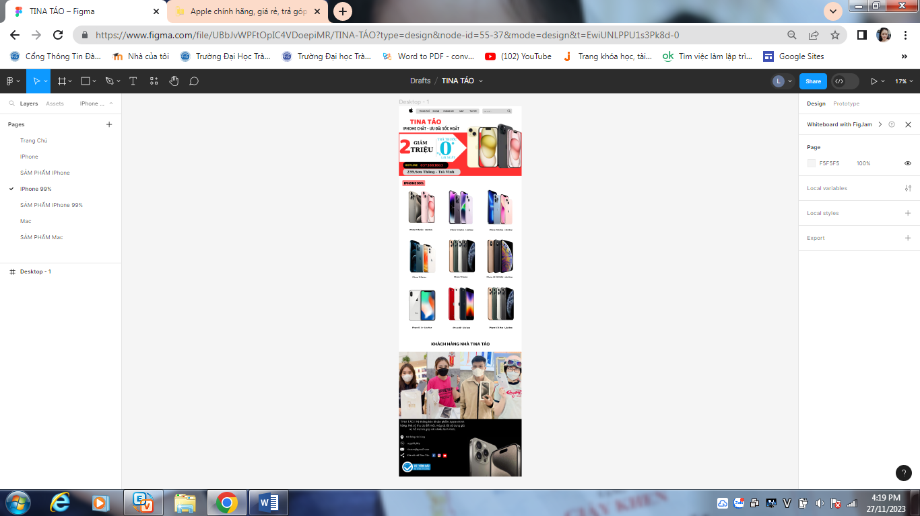

1.3 Tham khảo youtobe trang https://www.youtube.com/watch?v=kFjsKuzTm04